

**Progress Report 4:**

**First Prototype**

**Team 14: GOSH: App for child growth charts in R** *Saleh Khalil saleh.khalil.17@ucl.ac.uk*

**Rajan Hirani** rajan.hirani.17@ucl.ac.uk

**Saleh Khalil** saleh.khalil.17@ucl.ac.uk

**Sander Da Mata Miranda** sander.miranda.17@ucl.ac.uk

**COMP103P Applied Software Development**

**March 9, 2018**

Department of Computer Science

University College London

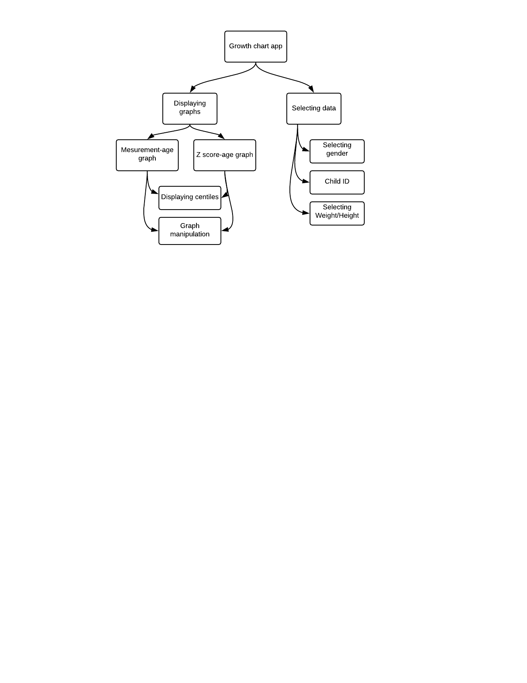**System Architecture:**

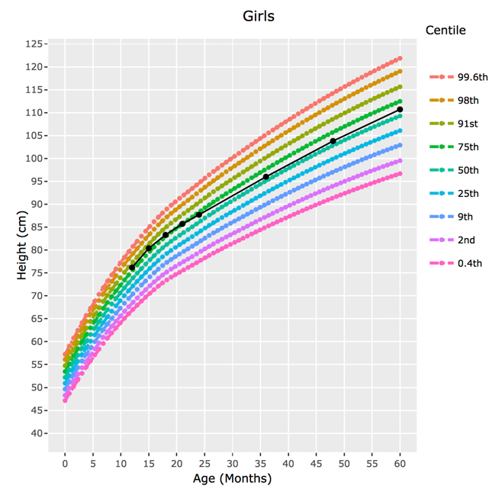**Displaying the measurement-age graph:**

This component of the system takes in the input data and calculates the measurement using the LMS formula provided by Prof Cole (Client). This measurement is then plotted on a graph against age. The multi-coloured lines on the graph show the different centiles and the black line shows the individual data selected from the data set.

**Displaying the z-score graph:**

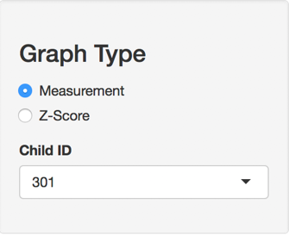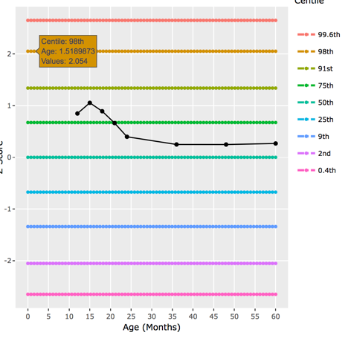We added the functionality of showing a graph that displays how many standard deviations above or below the mean the child is. This graph provides additional information about each child’s growth.

**Selecting Child data:**

We added a feature which allows the user to view individual child data on each graph to see how their data compared to the other centiles.

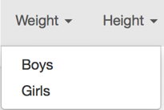**Choice of data:**

There is a feature within our program that allows the user to swap between weights and heights and whether it’s for boys and girls.

**Graph manipulation:**

The library we used to display the graphs has a group of built in features that allows the user to zoom in/out on points in the graph, save the graph as a .png file etc.

**Front-end Technologies:**

**R:** A statistical programming language that we used to display the graphs and the processing required to calculate the data for the graph. We used a library called plotly to display the graphs.

**R shiny:** An add-on to R that allows us to store the R program on a website. This lets our users to access our program in all platforms with web based functionality.

**Achievement table:**

|  |  |  |  |  |
| --- | --- | --- | --- | --- |
| ID | Requirements | Priority | State | Contributors |
| 1 | Plotting of serial measurements of an individual on a normal growth chart with centile detection | Must | **✓** | All |
| 2 | Plot weight and height growth charts | Must | **✓** | Rajan, Saleh |
| 3 | Have web app functionality | Must | **✓** | All |
| 4 | Use GOSH’s data to produce growth charts | Must | **✓** | Rajan, Saleh |
| 5 | Show growth trajectory using the data that is inputted | Should | **✓** | All |
| 6 | Integrated with SMART on FHIR so it can be compatible with any health centre that uses SMART on FHIR for their data storage | Should | **X** | All |
| 7 | Have some functionality to output data to a file format (pdf Prefered) | Could | ½ **✓**  .png format | All |
| 8 | Have Functionality for data security | Could | **X** | All |
| 9 | Have the app run in a mobile browser | Could | **✓** | All |
| Key functionality (Must/Should) | | **83%** Complete | | |
| Optional functionality (Could) | | **50%** Complete | | |